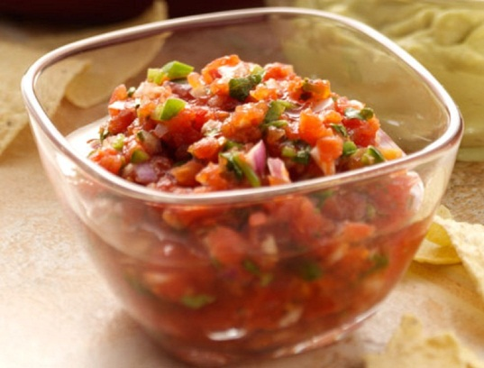

Salsa

1 small red onion, minced
4 – 5 large tomatoes, diced
1 – 2 cloves garlic, minced
1 jalapeno pepper, seeded and chopped
1 Tbsp lime juice
1 tsp olive oil
¼ tsp salt
¼ cup fresh cilantro, minced

Mix all ingredients and refrigerate for a couple hours. Serve with tortilla chips.

Be careful not to touch your eyes after chopping a hot pepper!

