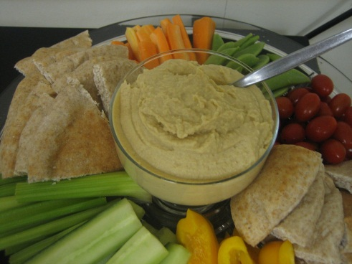
Garbanzo (Chick Pea) Hummus

In a food processor blend:

1 can (19oz / 540 mL) garbanzo beans (chick peas), rinsed
2 garlic cloves, roughly chopped
1 Tbsp tahini
6 Tbsp lemon juice
2 Tbsp olive oil
1 - 2 tsp ground cumin
3 drops hot sauce (can add more or less of this according to your taste)
2 Tbsp parsley
Salt to taste
Warm water – add this slowly until desired consistency is achieved

It best to let the hummus sit in the fridge for a while for the flavors to develop but you can eat it right away if you like. Serve with pita chips, celery, carrots, or any other veggies you like.

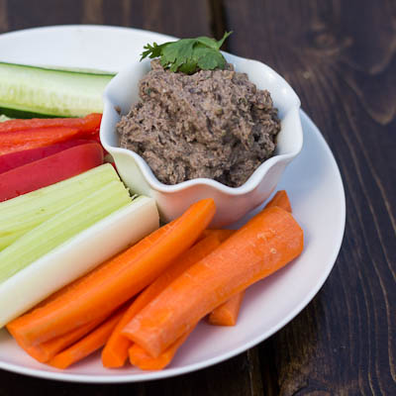
Black Bean Hummus

In a food processor blend:

1 can (19oz / 540 mL) black bean, rinsed
2 garlic cloves, roughly chopped
1 Tbsp tahini – this can be omitted if you don’t like tahini
6 Tbsp lime juice
2 Tbsp olive oil (can substitute other oils, like canola, sesame, etc.)
1 – 2 tsp ground cumin
1 – 2 tsp ground coriander
5 drops hot sauce (can add more or less of this according to your taste)
2 Tbsp cilantro
Salt to taste
Warm water – add this slowly until desired consistency is achieved

It best to let the hummus sit in the fridge for a while for the flavors to develop but you can eat it right away if you like. Serve with pita chips, celery, carrots, or any other veggies you like.
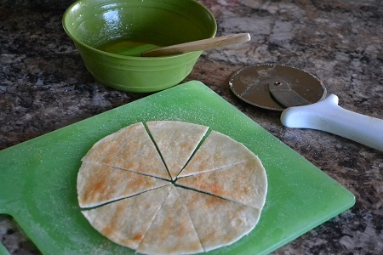

Pita Chips
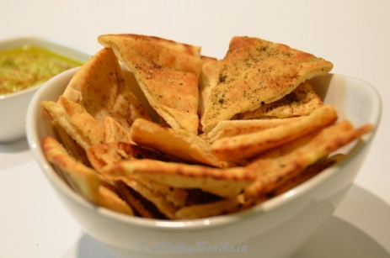
Cut 1 or 2 pita rounds into triangles. Brush with olive or canola oil, sprinkle with salt, pepper, and sesame seeds if you like and bake in an oven or toaster oven at 350ºF until lightly brown. Serve warm.

Tahini is a paste, much like peanut butter, but made from sesame seeds. It has a slightly bitter taste.

