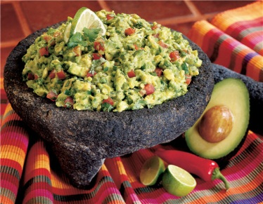

Guacamole

1 avocado, diced
1 medium tomato, diced
½ of a small red onion, minced
1 Tbsp lime juice
½ tsp chili powder
½ tsp cumin
½ tsp salt
½ tsp black pepper
2 Tbsp cilantro, chopped finely
Splash of olive oil
½ - 1 chipotle pepper in adobo sauce, minced (optional)

Mix all ingredients together and serve immediately with tortilla chips.

