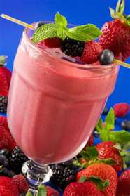
Fruit Smoothie
Makes 2-3 servings

In a blender, mix until smooth:

1 cup fresh or frozen berries
½ banana (cut into 1 inch pieces)
¼ cup orange juice
½ cup vanilla yogurt
1 cup ice cubes

Pour into glasses and enjoy!

