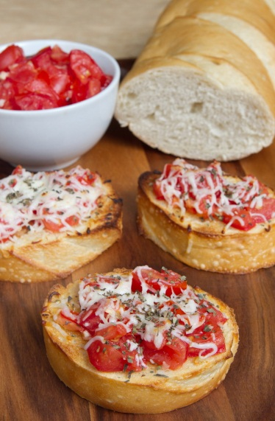

Bruschetta

6 or 7 ripe tomatoes
2 cloves garlic, minced
1 Tbsp extra virgin olive oil
1 tsp balsamic vinegar
6-8 fresh basil leaves, chopped
Salt and freshly ground black pepper to taste

1 baguette French bread or similar Italian bread
olive oil for brushing
grated parmesan cheese

Combine the tomatoes, garlic, oil, vinegar, basil, salt and pepper in a bowl. Refrigerate for an hour or so to let the flavors combine.
Slice the bread into ½ inch thick slices (straight across or diagonal cuts) and brush with olive oil. Toast in an oven or toaster oven at 350ºF until just starting to turn golden. You want them to still be a bit soft, not hard and crunchy.
Top bread slices with tomato mixture and sprinkle with grated parmesan cheese. Serve at once.

