**Landscape Drawing**

Using a photograph or any other source of landscape picture, create a landscape drawing in pencil, charcoal or pen and ink.

A few guidelines as you develop your landscape project:



Artists throughout history and in many different cultures have found the ratio of 1 to 1.618 is aesthetically pleasing. This ratio can also be obtained by dividing a line so that the short and long pieces have the same proportion (1 to 1.61) as the long piece does to the length of the original line.

**Rule of thirds**

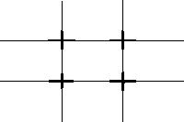The most basic rule of composition of drawing is the rule of thirds. The rule states that the focus of most images will fall within one of four intersections one third in into the drawing.

Using the Rule of Thirds helps produce nicely balanced, easy on the eye, pictures. Once you have got the hang of the Rule of Thirds you will very quickly want to break it! This is fine. 'Rules' are best used as guidelines and if you can create a better image by bending or ignoring rules then go for it!

**Where is the light?**

It is so important to decide where the light is coming from before you begin your landscape drawing – it affects everything you do.

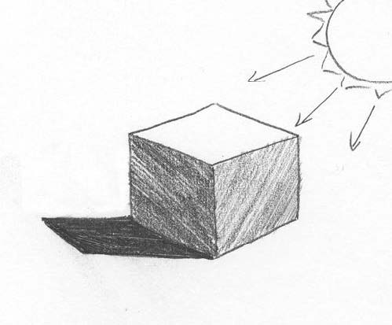Most things in our environment beg to have three-dimensionality and form. Light and shading play an important role in drawing realistically.

I find the best comparison to make is to use a cube. In order to create this three-dimensional form we have to use light and shadow. The plane with the most direct sunlight is the brightest. The plane with the no sunlight is the darkest. With a strong light, the shadow will be short and dark.

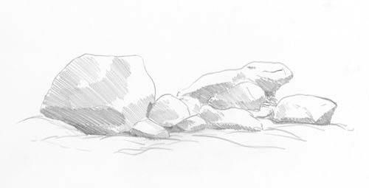So, with light from this direction, rocks might look like this….