Portrait Assignment
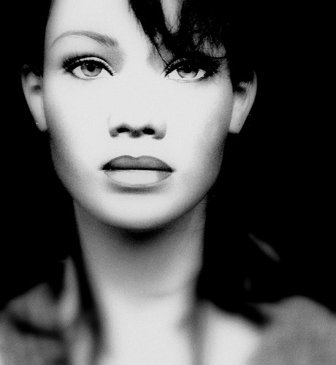
This assignment examines light and shadow in drawing the human face. Please choose one of the assignments below to complete and hand in. One idea is to work with your light source and take multiple photographs to create one you find interesting and can use for your work. This means that composition and principles of good design can and should be utilized.
1. Draw a portrait using light and shadow. In order to achieve strong gradations and a sense of form, place a light from different angles than normal. These can be under the chin, behind the head or from the top. This can be in graphite pencil or colored pencil.
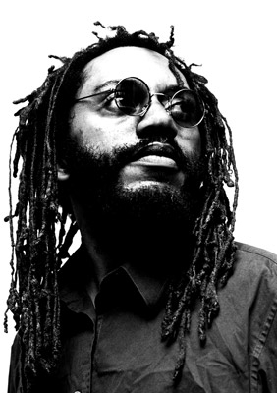
2. Draw yourself using a strong light source on one side of your face. Use a mirror and try to have some expression. Focus on the strong shadows created by the light. Feel free to block in large areas with a lesser amount of detail.
