Still Life Study Assignment
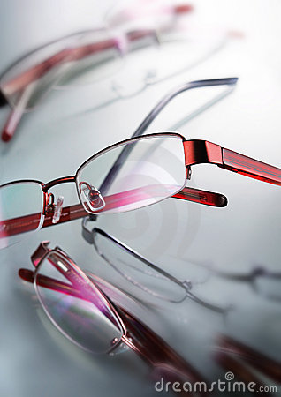
Make the image reach all the way to the edges of the page. Demonstrate what you know about point of view, emphasis, composition, positive and negative space, etc. This is a two part assignment – your best single item still life and your still life composition. These are to be completed in black and white, using a medium of your choice.

Part 1
From this list, choose three different subjects to draw. You will hand in your best of these three drawings.
- Creative views of your car, bicycle, skateboard, etc.
- A single flower with all its leaves, etc.
- A cluttered place close-up
- A pile of dishes sitting on the sink
- Your favorite food with the wrapper included, and product showing
- A close up set of 3-5 pieces of popped popcorn
- A close up of the various pieces from a game, the board, box, etc.
- A set of keys and a couple other items from your pocket or purse
- Your shoes or sandals (off your feet)
- Your sunglasses and what they reflect
- Your computer from an angle you do not usually view it, cords and all
- Something you view from a prone position looking up at whatever it is
Part 2
Arrange three related objects (3 kitchen items, 3 shoes, sports equipment, etc.) into a composition. Draw on one page using a light source and shading

