**Art Techniques Assignment**

You are presented with five assignments that deal with art techniques. These include contour, perspective, negative space and metamorphosis drawing as well as shading to achieve realism. You are encouraged to do all of these assignments and add them to your portfolio. For this course, you are required to choose your best three assignments and hand them in for marking.

**Contour Technique**

1. Do a contour drawing of a hand or a plant or a skull or a still life. Make sure it is pure contour.

2. Take a piece of continuous wire and try to bend the wire in the same movements of the contour line to convert your drawing into a sculpture. Of course, you will need to think what it takes to convert two dimensions into three dimensions.

**Perspective drawing**

There are two types of perspective:

* one-point perspective
* two-point perspective

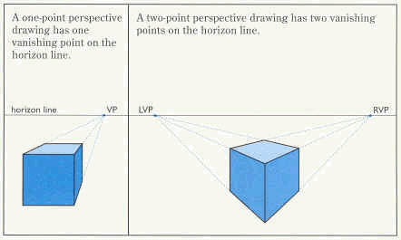

The horizon line and vanishing point are two important concepts related to perspective. On a clear, sunny day look outdoors and notice where the sky meets the ground. This horizontal line runs from left to right across your field of vision. It represents the point beyond which things disappear from view. The vanishing point is the point on the horizon where lines appear to converge.

Create a two point perspective drawing of a building of your choice. Remember that you will be looking at the building from a corner view. Pay special attention to the principles of two point perspective and retain lightly drawn lines to the two vanishing points. Complete shading to give the drawing realism.

**Metamorphosis Drawing**

Draw or create using your computer, the transition of one object into another. A couple of examples are given.

This website can also be an inspiration...

<http://www.abc.net.au/rollercoaster/rollermache/animation.htm>



**Negative space**

Using the principles of negative space, create a composition of your choice.

**Shading to create three dimensional effects**

Choose either a cylinder or a sphere to demonstrate how shading can create a three dimensional drawing. Be sure to identify the direction the light is coming from early in your work. Use any form of shading you would like (cross hatching, pointillism, circular lines…)