Portrait Drawing
Your assignment is to create a portrait drawing using pencil, charcoal or pen & ink. For many of us this is a challenging and important assignment.
Here is site that will take you step by step in the creation of a portrait of a young man. There are also many great sites on Youtube.
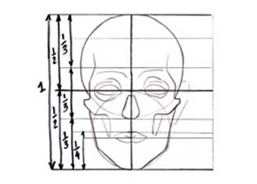
http://www.drawspace.com/lessons/u10/joel-allan
Some general guidelines on the proportions of the human face:
- Start with a 3 by 4 oval.
- The pupils are in the middle of the head, top to bottom.
- The bottom of the nose is between the pupils and bottom of the chin.
- 1/3 below the nose is between the lips.
- 2/3's below the nose is the chin crease.
Helpful hints?
Use a scrap of paper under your hand when you are drawing, as a "shield." That way you won't get graphite smeared on your drawing as you work.
While working on a drawing, frequently look at your drawing in the mirror. It is a great way to "weed out" problem areas in your drawing before you work any further. It also teaches you where your "problem areas" typically tend to be, which will help you improve next time.
Look at the drawing upside-down. This will help you see if anything is crooked, or lopsided (crooked eyes, mouth, etc.). Drawing upside-down helps you to see things abstractly, and assists in drawing accurately.
Draw subjects you like. Don't let anyone around you tell you that your portrait choices are "silly" or "weird." Please yourself.
Don't take yourself too seriously. Have fun.
Keep a sketchbook. Carry it with you whenever you can. Fill it up with lots of drawings. Have fun, and please yourself. It's your sketchbook!

