**Drawing Techniques Assignment**

You are presented with five assignments that deal with basic drawing techniques. These include gesture , contour, perspective, negative space and upside down drawing. You are encouraged to do all of these assignments and add them to your portfolio. For this course, you are required to choose your best three assignments and hand them in for marking.

**Gesture Drawing**

1. What is a gesture drawing?

2. Ask a friend to model for you. Running, sweeping, swinging, or climbing are suitable movements to use when doing gesture drawings. Any movement sequence can be repeated by your model until you get the knack of gesture drawing.

Watch your friend go through a particular motion. Then, train your eyes on the figure and let your pencil move widely on the page, keeping the line(s) continuous. "Feel" the movement being produced. Let lines cross over each other while you record the movement. There is no need to keep glancing at your work because you are not producing a refined drawing.

If you cannot get someone to pose for you, turn to a sports channel on television or find some photos of moving figures and use these as a basis for your gesture drawings.

Don't be discouraged if your first few attempts don't turn out as well as you expected. At first your end result will seem disjointed. It may take more practice than just a few tries to develop reasonable skills in creating gesture sketches. After much practice, your drawings will improve in accuracy and speed.

3. Move your hand in several positions. Sketch a gesture drawing of your hand in one of the positions.

4. Go through your favorite magazine or newspaper and pick out five pictures that interest you. These pictures should show movement. Do a gesture drawing of each.

5. Look closely at the following picture of the horse. Using paper the size of this page, sketch a gesture drawing of the horse.

**Contour Drawing**

In this activity you were introduced to contour drawings, an unusual but visually interesting way of drawing. In this drawing, you study your subject and define its edges and surface ridges with a pencil on paper. You do not look at your drawing paper at any time while your pencil is moving.

1. What is a contour drawing?

2. Make a blind contour drawing of an apple, a pencil, and a cup.

3. Find a figure or object that interests you. Draw a complex contour drawing of it.

4. Use complex contour drawing to render your hand in at least four different positions. Create as much detail as you can using this drawing technique.

**Perspective Drawing**

1. For a first assignment in one point perspective, make a one point perspective drawing using rectangles

Use 18 by 24 inch paper to do a one-point perspective drawing using rectangles with a variety of sizes. Overlap some. Make a vanishing point on an imaginary horizontal line. connect the 'sides' of the boxes to the vanishing point. These may be colored with your choice of medium.

2. One point perspective initials

Make your initials in squares off letters, approximately 2 inches thick. Make a vanishing point somewhere on the page. Draw the sides of the letters off to the vanishing point.

3. Using one point perspective, make the interior of a room of your choice**.**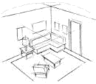

a. Draw lightly. First draw a horizontal line near the center of the paper. Place a dot (the vanishing point) somewhere on the line.

b. While some lines on the drawing will slant to lead to the dot, the vertical and horizontal lines in the drawing are parallel to the edges of the paper.

c. Use a ruler to draw vertical lines to represent walls, doors, windows and furniture in the room.

d. Use a ruler to draw a line from the top of a vertical line and draw to the vanishing point. Do the same with the bottom of the vertical line. Erase all extra lines on your completed drawing.

This website may help with this assignment:

<http://www.technologystudent.com/designpro/roomper1.htm>

**Negative Space Drawing**

Please choose one of the following or objects of your own choice

Assignment A

STEP 1

Carefully examine the basketball photograph. The shape and color of the objects in this picture make this picture unique. Note the interesting angle of this picture. Try focusing on the blue area of the picture.

STEP 2

Draw an outline drawing of all of the objects in the picture on your paper so it completely fills the paper - touching at least three of the sides. You may use grid drawing if you wish.

STEP 3

With a single color marker, color in everything that is not an object in the foreground. You will be coloring in all the "negative" space. What remains white is the foreground of the photograph.

Assignment B

STEP 1

Carefully examine the antique chair photograph. Try focusing on the background area of the picture.

STEP 2

Draw an outline drawing of the object in the picture on your paper so it completely fills the paper - touching at least three of the sides. You may use grid drawing if you wish.

STEP 3

With a single color marker, color in everything that is not an object in the foreground. You will be coloring in all the "negative" space. What remains white is the foreground of the photograph.

Assignment C

STEP 1

Carefully examine the trumpet photograph. Try focusing on the background area of the picture.

STEP 2

Draw an outline drawing of the object in the picture on your paper so it completely fills the paper - touching at least three of the sides. You may use grid drawing if you wish.

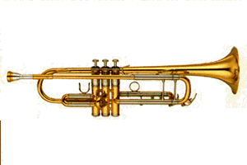STEP 3

With a single color marker, color in everything that is not an object in the foreground. You will be coloring in all the "negative" space. What remains white is the foreground of the photograph.

Upside Down Drawing



Do you see a young lady or an old woman in this picture. It depends on **how** you look at it!

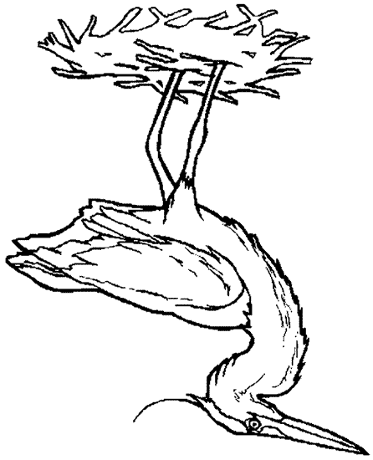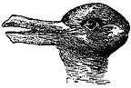

Do you see a duck or a rabbit in this picture. Visual thinkers can see **both**!

Please complete an upside down drawing of the picture provided, following the steps given:

1. Before you begin to draw, look at the upside down picture. See how the lines fit together and observe the negative and positive space.

2. When you start drawing, begin at the top and copy each line, putting it all together like it was a jig saw puzzle.

3. Keep observing how the lines fit together.

4. Remember, like any new technique, you will get better with practice.

Your best drawing should go to your portfolio - labelled and dated.