

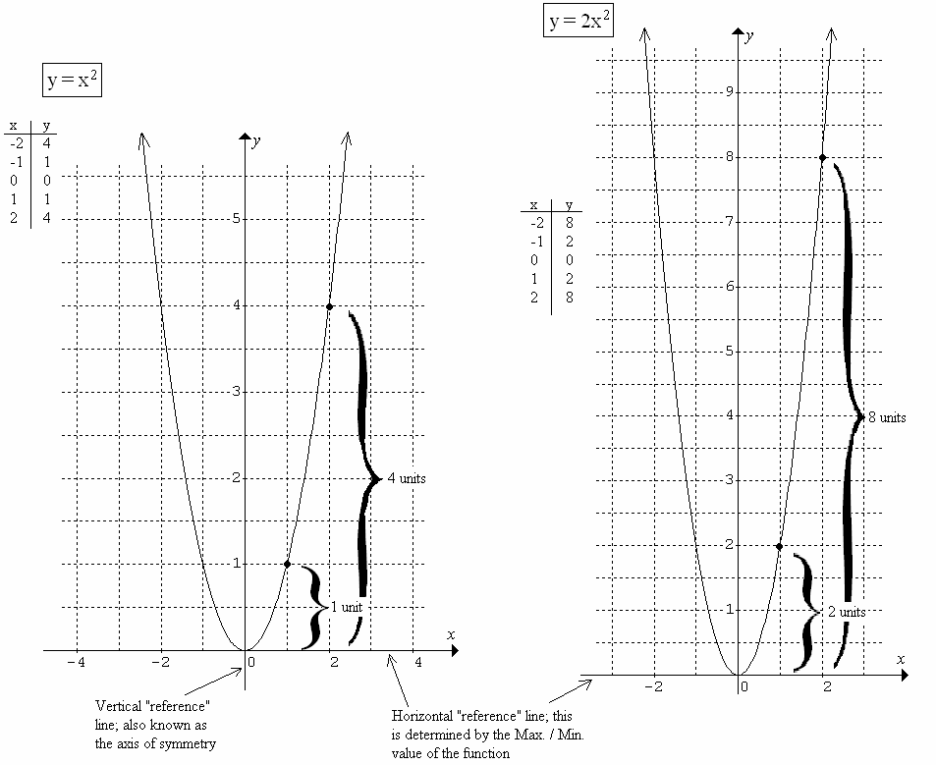

Consider the following functions:

Consider the vertical distance from the horizontal reference line for the functions  and .

  is the minimum 

(1, 1) When , the vertical (1, 2) When , the vertical

distance from  is +1 unit distance from  is +2 units

(2, 4) When , the vertical (2, 8) When , the vertical

distance from  is +4 units distance from  is +8 units

(3, 9) When , the vertical (3, 18) When , the vertical

distance from  is +9 units distance from  is +18 units

Conclusions: The vertical distance from the line y = 0 (Min/Max value) for the function  is always twice as large as that for the function.



Consider:

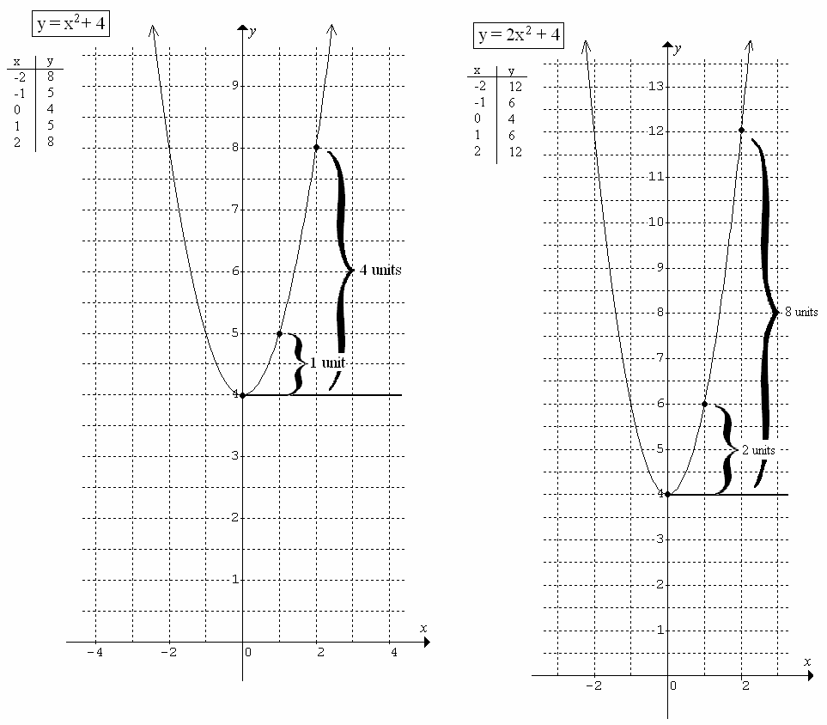

Findings:

  is the horizontal reference line 

(1, 5) When , the vertical (1, 6) When , the vertical

distance from  is +1 unit. distance from  is +2 units.

(2, 8) When , the vertical (2, 12) When, the vertical

distance from  is +4 units. distance from  is +8 units.

Conclusions:

Compare  to 

\*  is the horizontal reference line

\* the ‘2’ in  doubles the distance from the horizontal reference line to any point on the function 



Consider the following:

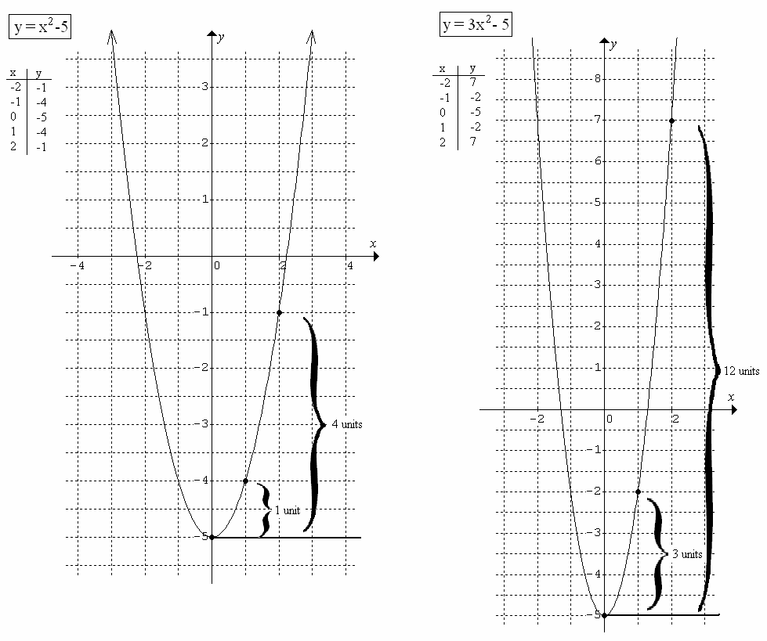

Findings:

  is the horizontal reference line 

(1, -4) When , the vertical (1, -2) When , the vertical

distance from  is +1 unit distance from  is +3 units

(2, -1) When , the vertical (2, 7) When , the vertical

distance from  is +4 units distance from  is +12 units

In the function, the “3” causes the vertical distance from  to triple when compared to that for the function .



Consider one more example:

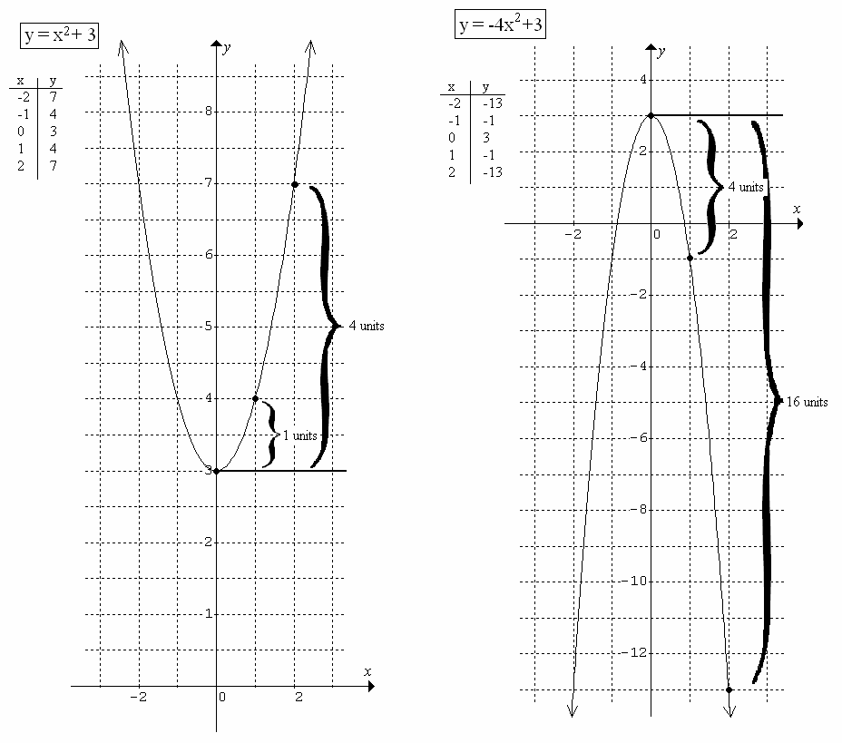

Findings:

  is our horizontal reference 

(1, 4) When , the vertical (1, -1) When , the vertical

distance from  is +1 unit distance from  is -4 units

(2, 7) When , the vertical (2, -13) When , the vertical

distance from is +4 units distance from  is -16 units

Conclusions:

The “ – “ sign in  causes a reflection in the line .

Relate these findings to the  notation.

 --transformation 

(2, 5) (?, ?)

(2, ?) same -value since no change affecting ‘’

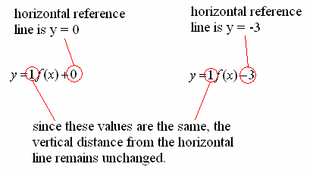

i.e.: (2, 5) When , the vertical

distance from  is +5 units

(2, ) When , the vertical

distance from  is +5 units

… therefore, the point is (2, 2)

Consider the following:

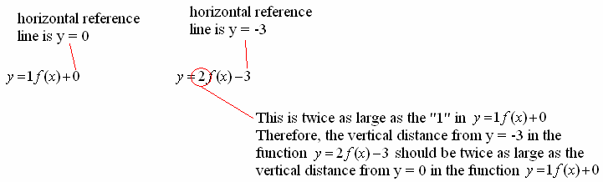

 

(2, 5) When , the vertical (2, ) When , the vertical

distance from  is +5 units distance from  should be +10 units

… therefore, the point becomes (2, 7)

Given the point (-3, 8) on the function defined by  

Reference line:  (-3, 8) When , the vertical

distance from is +8 units← This is the vertical reference distance for each

ordered pair on the transformed function.

Determine the transformed ordered pairs for the following functions:

Function Reference line Vertical distance Transformed point

From reference line

  +8 ←(1x8) (-3, -2)

  +8 ←(1x8) (-3, 11)

  +16 ←(2x8) (-3, 16)

  +40 ←(5x8) (-3, 33)

  -24 ←(-3x8) (-3, -19)

  -4 ←(-½x8) (-3, -1)