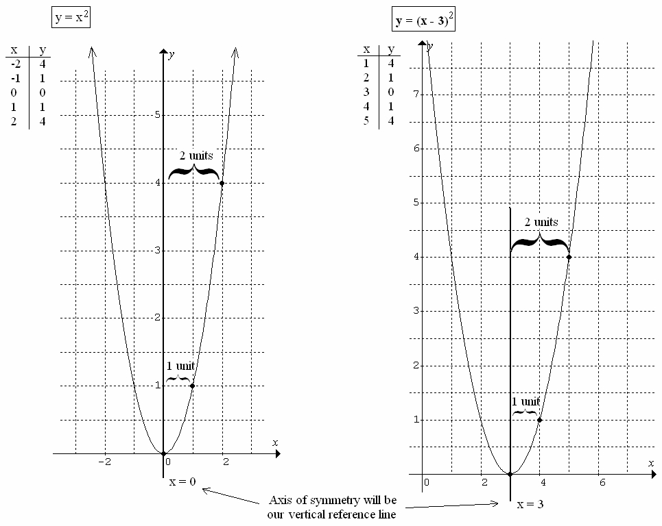

Consider the functions below:

Findings:

 

(1, 1) When , the horizontal (4, 1) When , the horizontal

distance from the vertical reference distance from the vertical reference line

line () is +1 unit. () is +1 unit.

(2, 4) When , the horizontal (5, 4) When , the horizontal

distance from the vertical reference distance from the vertical reference

line is +2 units. line is +2 units.

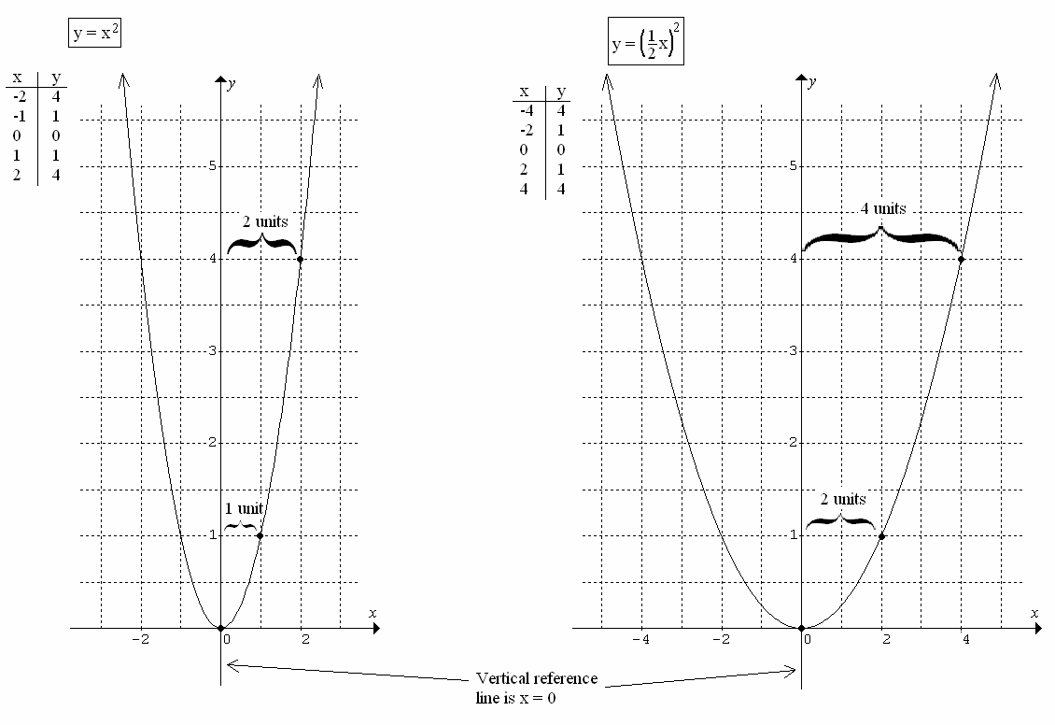

Consider another pair of functions:

Findings:

 

(1, 1) When , the horizontal (2, 1) When , the horizontal

distance from the vertical reference distance from the vertical reference

line is +1 unit line is +2 units

(2, 4) When , the horizontal (4, 4) When , the horizontal

distance from the vertical reference distance from the vertical reference

line is +2 units line is +4 units

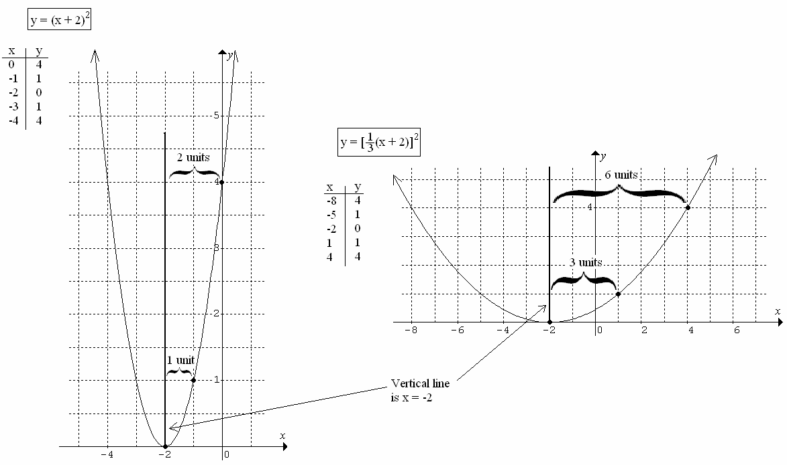

Another:

Findings:

 

(0, 4) When , the horizontal (4, 4) When , the horizontal

distance from the vertical reference distance from the vertical reference

line is +2 units line is +6 units

(-1, 1) When , the horizontal (1, 1) When , the horizontal distance from the vertical reference distance from the vertical reference

line is +1 units line is +3 units

Conclusions: The horizontal distance from the vertical reference line in the previous examples appears to be related to the number multiplied by  prior to applying the exponent.

Compare the following functions to  and its table of values shown.

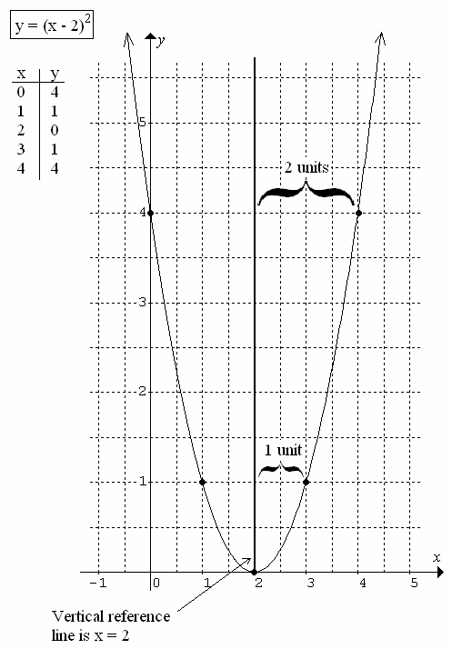



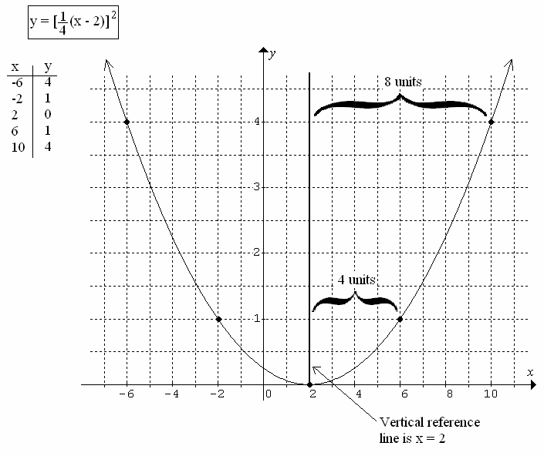

The horizontal distances from the vertical reference line on the function  are 4 times that of the function .



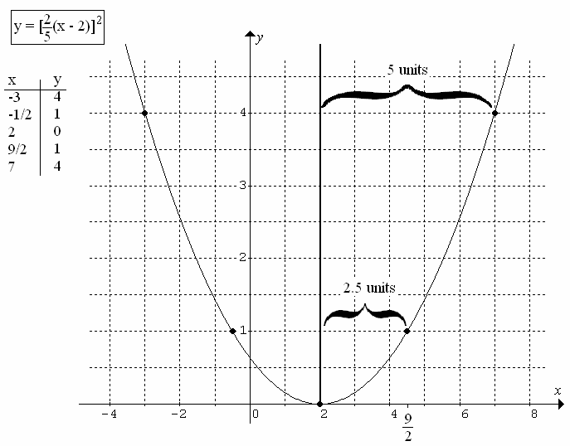

The horizontal distances from the vertical reference line on the function  are 2.5 times what the corresponding distances are on the function defined by .

Conclusions: Given the function , the horizontal stretch factor is determined by the reciprocal of .



**Summary:** For any quadratic function defined by +d, the following conclusions can be made…

**Horizontal reference line:** 

**Vertical reference line:** 

**Vertical stretch factor:**  *determines the relative distance from the horizontal reference line to a given point*

Consider the following: The point (2, 4) lies on the graph defined by the function . For the following transformations, determine the coordinates for the new ‘transformed’ point.

**stretch factor:**  *determines the relative distance from the vertical reference line to a given point*

|  |  |  |  |  |  |
| --- | --- | --- | --- | --- | --- |
| **Function** | **Vertical reference line** | **Horizontal reference line** | **Horizontal distance from vertical reference** | **Vertical distance from horizontal reference** | **Transformed ordered pair** |
| (original) |  |  | 2 units | 4 units | (2, 4) |
|  |  |  | +4 units  (2x2) | +4 units  (1x4) | (4, 4) |
|  |  |  | +6 units  (3x2) | +4 units  (1x4) | (4, 4) |
|  |  |  | +10 units  (5x2) | +4 units  (1x4) | (13, -3) |
|  |  |  | +14 units  (7x2) | +8 units  (2x4) | (6, -2) |
|  |  |  | +6 units  (3x2) | -20 units  (-5x4) | (11, -17) |
|  |  |  | -8 units  (-4x2) | +28 units  (7x4) | (-17, 20) |

Verify each of these transformed points algebraically using the transformed function to prove that it works; the students WILL buy into this.

Consider the function: The point (-3, 7) lies on the graph defined by the function . For the following transformations, determine the coordinates for the new ‘transformed’ point.

|  |  |  |  |  |  |
| --- | --- | --- | --- | --- | --- |
| **Function** | **Vertical reference line** | **Horizontal reference line** | **Horizontal distance from vertical reference** | **Vertical distance from horizontal reference** | **Transformed ordered pair** |
| (original) |  |  | -3 units | +7 units | (-3, 7) |
|  |  |  | -9 units  (3x original) | +14 units  (2x7) | (-4, 2) |
|  |  |  | +12 units  (-4x original) | -35 units  (-5x7) | (10, -44) |

