Converting a Sculpture to Basic Geometric Shapes
The assignment here is substituting geometric shapes for figurative images. Examine the following contemporary sculpture. Reinterpret the composition, but use only geometric and free form shapes and forms. Maintain the composition and proportions of the original work.

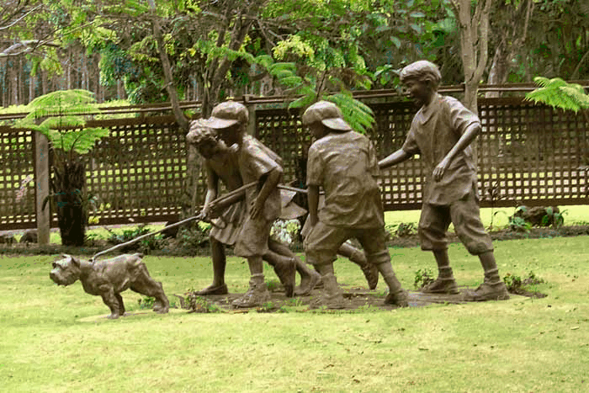
http://www.rdsaunders.com/WebG…tures/images/Sculptures-26.jpg

The sculpture is located in Hawaii, a place called Na Aina Kai, that means "Lands by the Sea" .The property stretches 1-1/2 miles from the ocean to the Kuhio Highway covering 240 acres, comprising 12 gardens, a maze in the shape of a flower, waterfalls, a lagoon, lakes, white sand beach, 60,000 hardwood trees and miles of walking trails. It is so large that one of the walking tours takes five hours and doesn't cover it all. The gardens also contain over 65 bronze sculptures, many of which were commissioned by the Doty's. They are carefully placed throughout the gardens, and some just pop up at you when you least expect it--such as at the end of a blind maze path

