**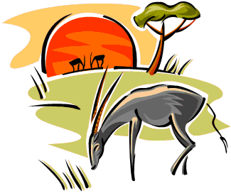Unit B Project – Dynamics**

1. Cheetah gets a hold of Gazelle’s leg and pulls with a force of 375 N [77° S of W], while Gazelle’s leg pulls back with a force of 164 N [23° N of W]. What is the net force (direction included) on Gazelle’s leg? What is the acceleration of its leg assuming its mass is 3.00 kg?
2. Cheetah, whose mass is 55 kg, drags Gazelle’s 40 kg bloody carcass back to his lair. What force does he need to apply on the carcass in order to drag it over the grassy plain that has a coefficient of kinetic friction of 0.20, assuming uniform motion?
3. A baboon is hot on the trail of the cheetah’s catch. Aware of this, the cheetah needs to drag the carcass faster. What force does he need to apply on the carcass in order to increase its speed from 2.0 m/s to 5.0 m/s in 3.0 s?
4. *an01421_*On the way to his lair, the cheetah has to go up a 6.24° gravel-covered hill. Assuming he is still traveling a t 5.0 m/s at the base of the hill, and, after traveling 13.2 m, he has slowed down to 0.55 m/s, what is the coefficient of kinetic friction between the carcass and the gravel if the cheetah is applying a force on the gazelle of 250 N parallel to the hill?